Model ricker

$$\frac{N_{i,t+1}}{N_{i,t}}=e^{r_{i}-α_{ii}N_{i,t}-α_{ij}N_{j,t}+{ran_time}_{i,t}}$$

ND = $1-\sqrt{\frac{a_{ij}a_{ji}}{a_{ii}a_{jj}}}$ FD = $\frac{r_{i}}{r_{j}}*\sqrt{\frac{a_{jj}a_{ji}}{a_{ii}a_{ij}}}$

$$\frac{1}{N_{i}}\frac{dN_{i}}{dt}=\frac{dln\left(N_{i}\right)}{dt}=\frac{\ln\left(N_{i,t+1}\right)-\ln\left(N_{i,t}\right)}{\left(t+1\right)-\left(t\right)}=\ln\left(\frac{N_{i,t+1}}{N_{i,t}}\right) (A.1)$$

$$ln\left(\frac{N_{i,t+1}}{N_{i,t}}\right)=r_{i}\left(1-\sum_{j=1}^{S}{α_{ij}N_{j}}\right)$$

$$\frac{\ln\left(N_{i,t+n}\right)-\ln\left(N_{i,t}\right)}{\left(t+n\right)-\left(t\right)}=\ln\left(\frac{N_{i,t+1}}{N_{i,t}}\right)/n$$

$$ln\left(\frac{N_{i,t+n}}{N_{i,t}}\right)/n=r_{i}\left(1-\sum_{j=1}^{S}{α_{ij}N_{j}}\right)$$

$$\frac{N_{i,t+n}}{N_{i,t}}=e^{（r_{i}-α_{ii}N_{i}-α_{ij}N_{j}+ran_{time}）*n}$$

Model BH

$$\frac{N_{i,t+1}}{N_{i,t}}=\frac{e^{r_{i}+{ran_time}_{i,t}}}{1+α_{ii}N_{i,t}{+α}_{ij}N_{j,t}}$$

Calculating integral and modified the logistic differential equation:

$$\frac{dN_{i}}{Ndt}=r-aN$$

we can get:

$$\frac{N_{i,t+1}}{N_{i,t}}=\frac{λ_{i}^{1}}{1+(\frac{λ_{i}^{1}-1}{K_{i}})N_{i,t}+k(\frac{λ_{i}^{1}-1}{K_{i}})N_{j,t}}$$

After that, we can write $\frac{λ_{i}^{1}-1}{K_{i}}=α_{ii} and α_{ij}=kα_{ii}$, then:

$$\frac{N_{i,t+1}}{N_{i,t}}=\frac{λ_{i}^{1}}{1+α_{ii}N_{i,t}{+α}_{ij}N_{j,t}}$$

ND = $1-\sqrt{\frac{a_{ij}a_{ji}}{a_{ii}a_{jj}}}$ FD = $\frac{e^{ri}-1}{e^{rj}-1}*\sqrt{\frac{a_{jj}a_{ji}}{a_{ii}a_{ij}}}$

$$\ln\left(\frac{N_{i,t+1}}{N_{i,t}}\right)=ln⁡(\frac{e^{r_{i}+{ran_{time}}_{i,t}}}{1+α_{ii}N_{i,t}{+α}_{ij}N_{j,t}})$$

$$\ln\left(\frac{N_{i,t+n}}{N_{i,t}}\right)/n=ln⁡(\frac{e^{r_{i}+{ran_{time}}_{i,t}}}{1+α_{ii}N_{i,t}{+α}_{ij}N_{j,t}})$$

Model BH_b1

$$\frac{N_{i,t+1}}{N_{i,t}}=\frac{e^{r_{i}+{ran_time}_{i,t}}}{{\left(1+α_{ii}N_{i,t}{+α}_{ij}N_{j,t}\right)}^{b_{i}}}$$

b > 0

ND = $1-\sqrt{\frac{a_{ij}a_{ji}}{a_{ii}a_{jj}}}$ FD = $\frac{({e^{ri})}^{1/bi}-1}{{{(e}^{rj})}^{1/bj}-1}*\sqrt{\frac{a_{jj}a_{ji}}{a_{ii}a_{ij}}}$

Model 4

$$\frac{N_{i,t+1}}{N_{i,t}}= e^{r_{i}+{ran_time}_{i,t}}$$

Model BH_log

$$\frac{N_{i,t+1}}{N_{i,t}}=\frac{e^{r_{i}+{ran_time}_{i,t}}}{1+α_{ii}{*log⁡(N}_{i,t}+1){+α}_{ij}*log⁡(N_{j,t}+1)}$$

ND = $1-\sqrt{\frac{a_{ij}a_{ji}}{a_{ii}a_{jj}}}$ FD = $\frac{e^{ri}-1}{e^{rj}-1}*\sqrt{\frac{a_{jj}a_{ji}}{a_{ii}a_{ij}}}$

Model BH_b2

$$\frac{N_{i,t+1}}{N_{i,t}}=\frac{e^{r_{i}+{ran_time}_{i,t}}}{{1+\left(α_{ii}N_{i,t}{+α}_{ij}N_{j,t}\right)}^{b_{i}}}$$

b > 0

ND = $1-\sqrt{\frac{a_{ij}a_{ji}}{a_{ii}a_{jj}}}$ FD = $\frac{({e^{ri}-1)}^{1/bi}}{({e^{rj}-1)}^{1/bj}}*\sqrt{\frac{a_{jj}a_{ji}}{a_{ii}a_{ij}}}$

Model ricker log

$$\frac{N_{i,t+1}}{N_{i,t}}=e^{r_{i}-α_{ii}{*ln⁡(N}_{i,t}+1)-α_{ij}*ln⁡(N_{j,t}+1)+{ran_time}_{i,t}}$$

ND = $1-\sqrt{\frac{a_{ij}a_{ji}}{a_{ii}a_{jj}}}$ FD = $\frac{r_{i}}{r_{j}}*\sqrt{\frac{a_{jj}a_{ji}}{a_{ii}a_{ij}}}$

yao

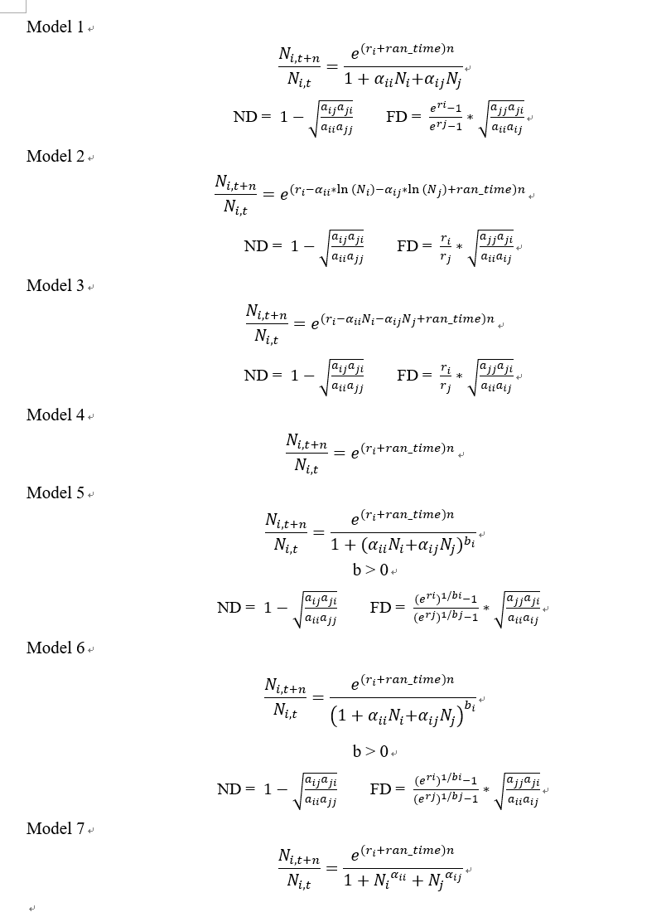

|  |  |  |  |
| --- | --- | --- | --- |
| Competition model | ΔELPD | SE ΔELPD | ELPD |
| $$\frac{N_{i,t+1}}{N_{i,t}}=e^{r_{i}-α_{ii}{*ln⁡(N}_{i,t}+1)-α_{ij}*ln⁡(N_{j,t}+1)+{ran_time}_{i,t}}$$ | -1.78 | 0.103 | -178.91 |
| $$\frac{N_{i,t+1}}{N_{i,t}}=\frac{e^{r_{i}+{ran_time}_{i,t}}}{{\left(1+α_{ii}N_{i,t}{+α}_{ij}N_{j,t}\right)}^{b_{i}}}$$ | -6.22 | 0.194 | -183.35 |
| $$\frac{N_{i,t+1}}{N_{i,t}}=\frac{e^{r_{i}+{ran_time}_{i,t}}}{1+α_{ii}N_{i,t}{+α}_{ij}N_{j,t}}$$ | -6.24 | 0.157 | -183.37 |
| $$\frac{N_{i,t+1}}{N_{i,t}}=\frac{e^{r_{i}+{ran_time}_{i,t}}}{{1+\left(α_{ii}N_{i,t}{+α}_{ij}N_{j,t}\right)}^{b_{i}}}$$ | -6.24 | 0.194 | -183.37 |
| $$\frac{N_{i,t+1}}{N_{i,t}}=\frac{e^{r_{i}+{ran_time}_{i,t}}}{1+α_{ii}{*log⁡(N}_{i,t}+1){+α}_{ij}*log⁡(N_{j,t}+1)}$$ | -6.45 | 0.174 | -183.58 |
| $$\frac{N_{i,t+1}}{N_{i,t}}= e^{r_{i}+{ran_time}_{i,t}}$$ | -6.52 | 0.239 | -183.65 |
| $$\frac{N_{i,t+1}}{N_{i,t}}=e^{(r_{i}-α_{ii}N_{i,t}-α_{ij}N_{j,t})^bi+{ran_time}_{i,t}}$$ | -8.50 | 0.148 | -185.63 |
| $$\frac{N_{i,t+1}}{N_{i,t}}=e^{r_{i}-{(α}_{ii}N_{i,t}+α_{ij}N_{j,t})^bi+{ran_time}_{i,t}}$$ |  |  |  |
| $$\frac{N_{i,t+1}}{N_{i,t}}=e^{r_{i}-α_{ii}N_{i,t}-α_{ij}N_{j,t}+{ran_time}_{i,t}}$$ |  |  |  |

Supp Methods

(e.g., )

Table S2 ,,,,,

|  |  |  |
| --- | --- | --- |
| Competition model | ref. in Fig. A2 | Competitive ability |
| $$\frac{N_{i,t+1}}{N_{i,t}}=\frac{λ_{i}}{1+α_{ii}N_{i}{+α}_{ij}N_{j}}$$ | (a) | $$\frac{λ_{i}-1}{\sqrt{α_{ii}α_{ij}}}$$ |
| $$\frac{N_{i,t+1}}{N_{i,t}}=\frac{λ_{i}}{{(1+α_{ii}N_{i}{+α}_{ij}N_{j})}^{b}}$$ | (b) | $$\frac{λ_{1}^{1/b}-1}{\sqrt{α_{ii}α_{ij}}}$$ |
| $$\frac{N_{i,t+1}}{N_{i,t}}=λ_{i}e^{-α_{ii}N_{i}-α_{ij}N_{j}}$$ | (c) | $$\frac{ln\left(λ_{i}\right)}{\sqrt{α_{ii}α_{ij}}}$$ |
| $$\frac{N_{i,t+1}}{N_{i,t}}=\frac{λ_{i}}{1+{N_{i}}^{α_{ii}}+{N_{j}}^{α_{ij}}}$$ | (d) | $$\frac{ln\left(λ_{i}-1\right)}{\sqrt{α_{ii}α_{ij}}}$$ |
| $$\frac{N_{i,t+1}}{N_{i,t}}=λ_{i}-α_{ii}N_{i}-α_{ij}N_{j}$$ | (e) | $$\frac{λ_{i}-1}{\sqrt{α_{ii}α_{ij}}}$$ |
| $$\frac{N_{i,t+1}}{N_{i,t}}=\frac{g_{i}λ_{i}}{1+α_{ii}g_{i}N_{i}{+α}_{ij}g_{j}N_{j}}+(1-g_{i})s_{i}$$ | not shown | $$\frac{\frac{λ_{i}g_{i}}{1-(1-g_{i})s_{i}}-1}{\sqrt{α_{ii}α_{ij}}}$$ |

Hart-2018-JEcol

Nature 2009

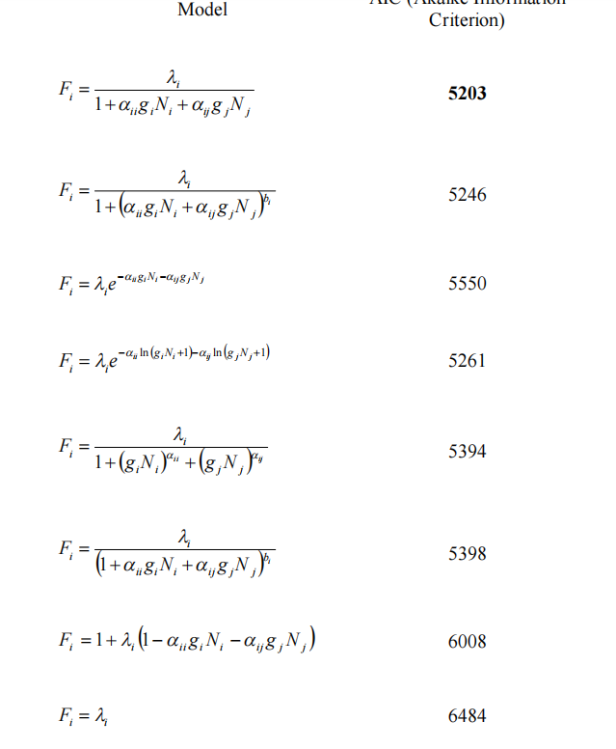

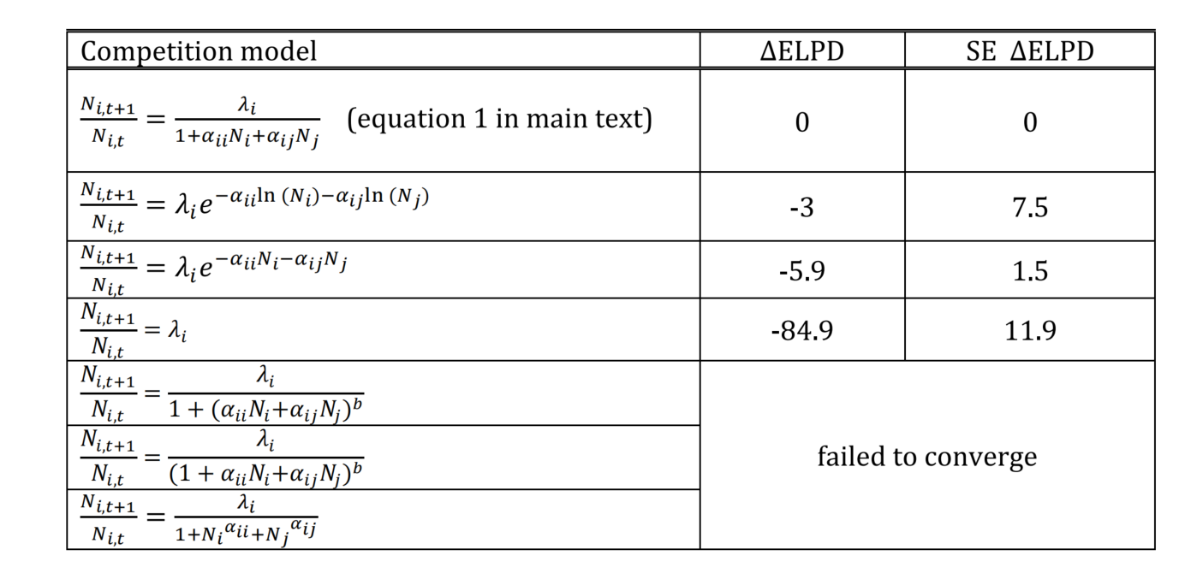

NEE 2022